A493-AM,N-NW- Kwakwaka'wakw**–Totem Pole-Owl-Bear-mid 20th century**

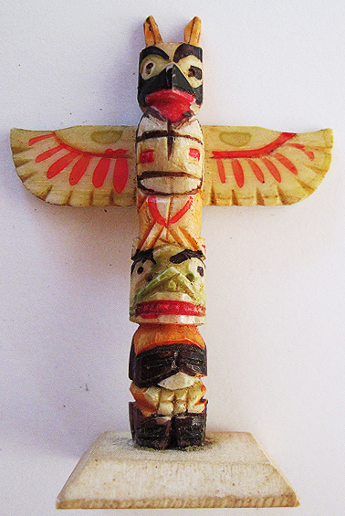 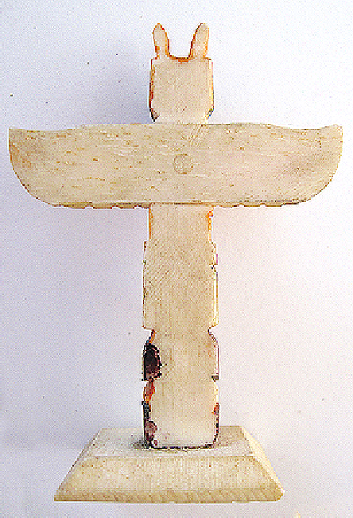

Figs. 1-2. Kwakwaka'wakw**–Totem Pole-Owl-Bear-mid 20th century**

**Case no.: 8**

**Accession Number: A493**

**Formal Label:** Kwakwaka'wakw**–Totem Pole-Owl-Bear-mid 20th century**

**Display Description:**

This rare totem pole is constructed of bone and carved with two of the most powerful mythological figures: the Owl perched on top of the Bear.

The Owl is one of the characters that appear in both the T?seka and T?a’sala ceremonies. Owl represents the “Wise One” and the keeper of knowledge. Owl is associated with ill fortune and is often the messenger of death. If Owl calls your name he is a calling you to join the spirits of the dead, and it is believed you will soon die. When the T?seka dance is performed the dancer will accentuate the distinctive bulging eyes and fierce expression of the mask with the owl-like movements, keeping his head forward and eyes straight ahead.

The Bear, on the other hand, is a symbol of power, courage, physical strength and leadership. Warriors wear bear claw necklaces for protection in battle. A Chief's daughter was abducted by a bear after picking berries when she stepped on Bear dung and curse all bears out loud for their lack of cleanliness. Two Bears nearby heard her and decided they would not tolerate such insolence. They felt she had to be punished. One Bear transformed himself into a very handsome man who approached this woman, and seductively lured her to accompany him to his mountain home. When she did, she fell in love with him and became partially Bear-like herself. She later married him and had twin cubs. Their children were born as little creatures that resembled bears who could metamorphose themselves into human form like their father. The woman's brothers eventually found her and, in an unequal contest, killed her husband. They returned to the village but the two bear sons did not feel comfortable and eventually left to return to the forest. All Bear Clan members are descended from this woman and her two sons.

**LC Classification: E99.K9**

**Date or Time Horizon:** Early 20th century

**Geographical Area:** Fort Rupert, northeastern Vancouver Island.

**Map, GPS coordinates:** 50º41'51.16" N 127º25'32.09" W

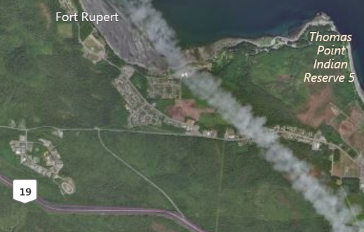

Fig. 3. Map of Fort Rupert and the Kwakwaka'wakw Reserve. After www.bing.com

**Cultural Affiliation:** Kwakwaka'wakw, Kwagu’ł band living at Fort Rupert

**Media:** Bone

**Dimensions:** H 99.50 mm, 3.92; W 99.05 mm, 3.11 in.

**Weight:** 23 gm, ¾ oz

**Condition: original**

**Provenance:** artists estate

**Discussion:**

Technically, the style and form of model totem poles changed in tandem with access to iron tools and supplies made available after contact with early Russian explorers and European settlers (Holm 1965: 5; Malin 1978: 13; Jonaitis 1991: 39, 54; Masco 1995: 42). Northwest Company and the Hudson Bay Trading Company, which built a trading post near Fort Rupert, in 1849 provided contact with other people. Metal carving tools were sharper and more efficient than their traditional counterparts, and modern synthetic paints allowed for more dramatic and durable coloration than did the plant and mineral based pigments previously used to decorate masks (Jonaitis 1991: 39, 54).

However, the role of the past is still evident in the conservatism among some sculptors who refer to the totem poles of the past for models in their current work. In this respect, older totem pole models are highly valued by the Kwakwaka'wakw as manifestations of ancestral spirits and supernatural beings. Northwest Coast tribes vary in their use of different myths and characters they configure in totem poles because unlike masks otem poles do not have performance as a method of engaging with and audience (Malin 1978: 47). Engagement , therefore, must come about by way of the viewer being able to read the configuration of entities on the totem pole silently. Often these totem poles like masks are “owned” by particular families and passed down by elders and chiefs to their immediate and extended families, they have a certain conservatism in their presentation in the potlatch and seasonal festivals, accruing histories that incrementally transform their meaning (Gosden and Marshall 1999: 172), which is reflected in the way sculptors create new totem poles as well as masks based on these transformations (Malin 1978:18-19; Ostrowitz and Jonaitis 1991: 251).

**References:**

Greenville, Bruce  
1998 Introduction in Down from the Shimmering Sky: Masks of the Northwest Coast, Peter Macnair, et al, 14-16. Vancouver, BC, Seattle: Douglas & McIntyre and University of Washington Press.

Hawthorn, Audrey  
1979 Kwakiutl Art. Seattle: University of Washington Press.

Holm, Bill  
1984 Form in Northwest Coast Art in Indian Art Traditions of the Northwest Coast, ed. Roy L. Carlson. Burnaby, B.C.: Archaeology Press & Simon Frasier University.  
1972 Crooked Beak of Heaven. Seattle: University of Washington Press.  
1965 Northwest Coast Indian Art. Seattle: University of Washington Press.

Jonaitis, ; Douglas Cole; Stacy Alyn Marcus; Lynton Gardiner. 1991 *Chiefly Feasts: The creation of an exhibition in Chiefly Feasts: The Enduring Kwakiutl Potlatch.* New York and Seattle: American Museum of Natural History and University of Washington Press.

Macnair, Peter  
1998 Power of the Shining Heavens in Down from the Shimmering Sky: Masks of the Northwest Coast. Vancouver and Seattle: Douglas & McIntyre and University of Washington Press.

Malin, Edward  
1999 Northwest Coast Indian Painting: House Fronts and Interior Screens. Portland, OR: Timber Press.  
1978 A World of Faces: Masks of the Northwest Coast Indians. Portland, OR: Timber Press.

Masco, Joseph1995 ’It is a Strict Law That Bids Us Dance’: Cosmologies, Colonialism, Death, and Ritual Authority in the Kwakwaka'wakw Potlatch, 1849 to 1922 in Comparative Studies in Society and History 37 (1): 41-75.

Ostrowitz, Judith, and Jonaitis, Aldona. 1991 “Postscript: The Treasures of Siwidi in Chiefly Feasts: The Enduring Kwakiutl Potlatch” In Aldona Jonaitis, et al., New York and Seattle: American Museum of Natural History and University of Washington Press.

Pollock, Donald**.** 1995 “Masks and the Semiotics of Identity,” The Journal of the Royal Anthropological Institute 1(3): 581-597.